**Practical No 2**

* **Set JAVA_HOME in environment variable**

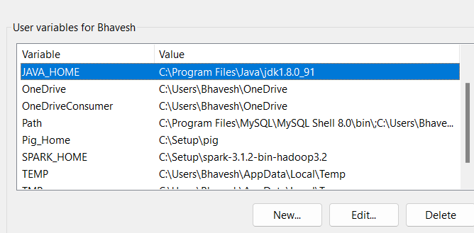

* **Set Hadoop_Home in environment variable**

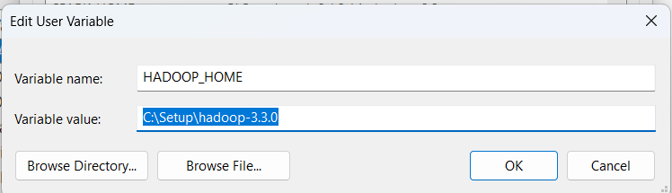

* **Run Hadoop start command to start hadoop 3.3.0**

**start-all.cmd**

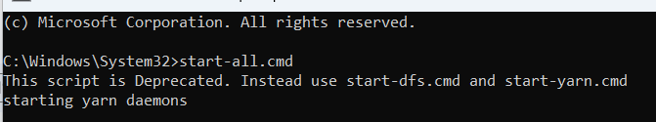

* **Check whether these 4 process are running or not**

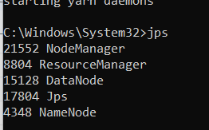

* **Create a directory “input” in HDFS.**

**hdfs dfs -mkdir /input**



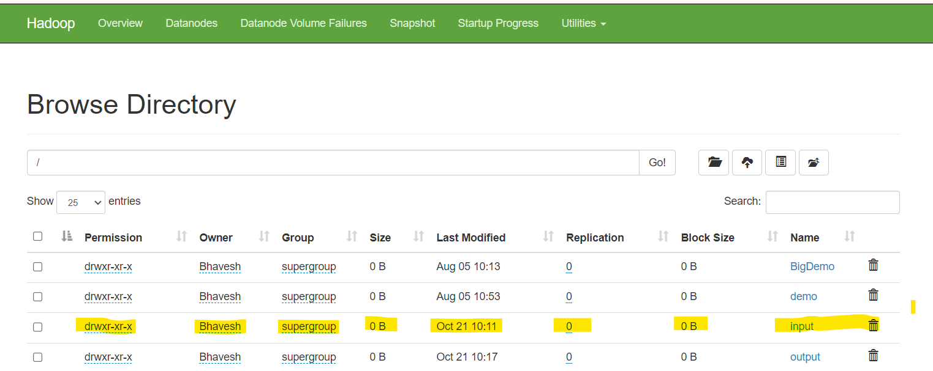

* **Upload or put local file “data.txt” to “input” directory in HDFS**



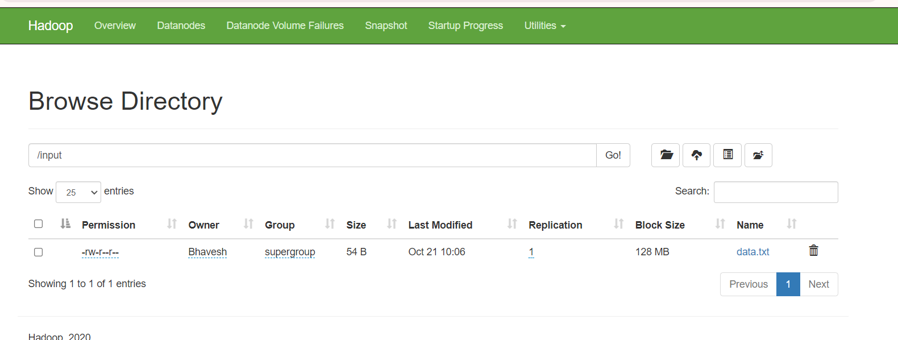

* **Run a jar file to count the number of words from “/input” directory and create output in “/output” directory.**

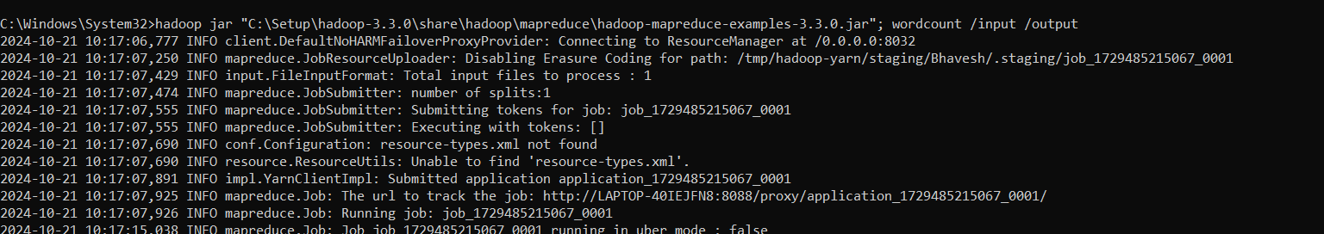

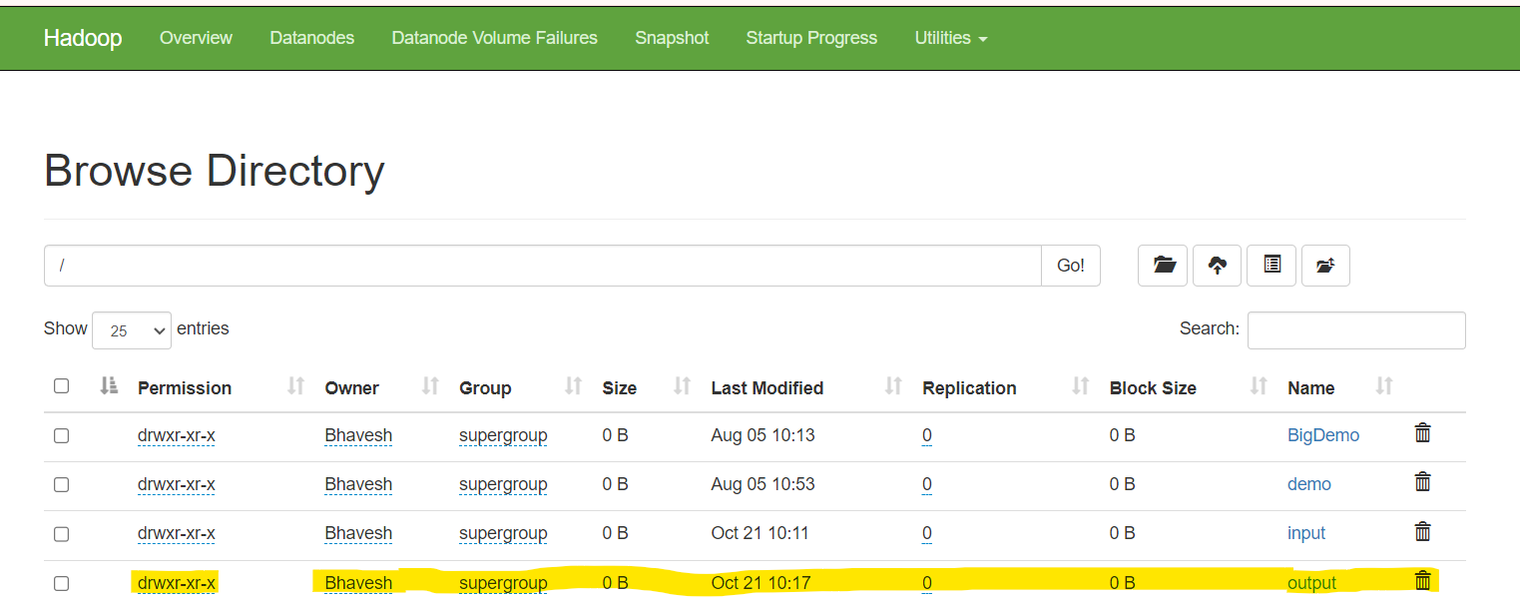

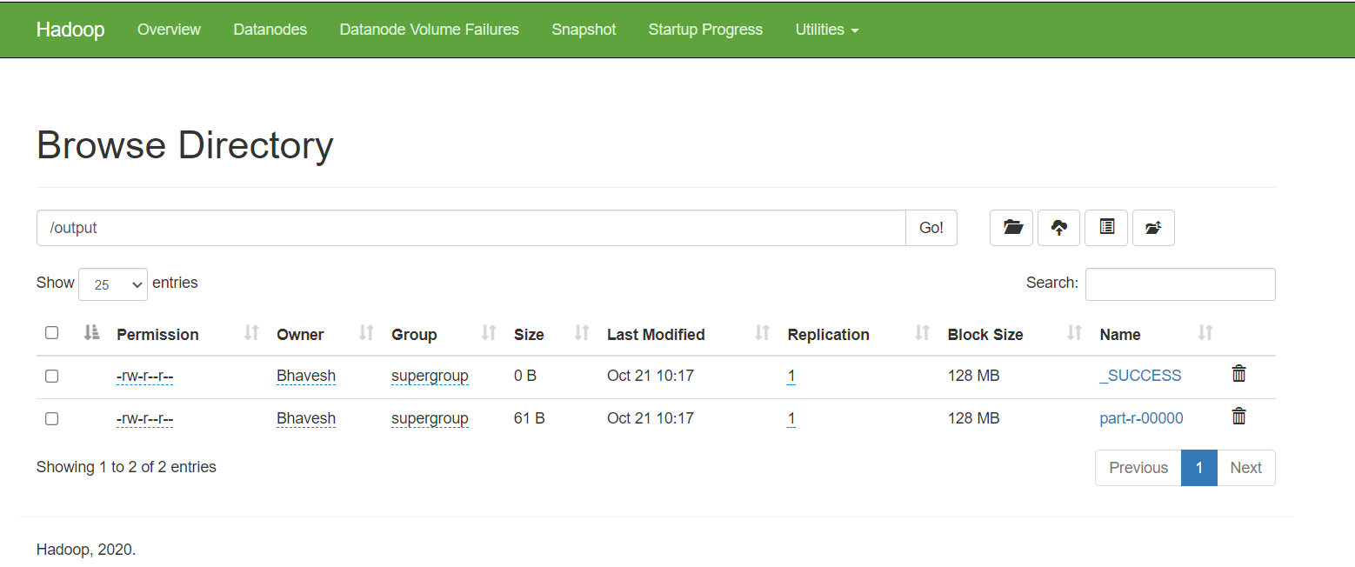

* **Find the output generated by Mapreduce wordcount in the “part-r-00000” file of the “/output” directory**

**hdfs dfs -cat /output/part-r-00000**

